EVENT TICKETING DAPP

16353881

PRASAMSA KONDAPANENI

**Overview :**

To create a decentralized application that allows users to mint, buy, sell, and verify event tickets as NFTs on the blockchain, ensuring transparency, authenticity, and ease of use.

**GITHUB:**

https://github.com/prasamsa12/event-ticketing-dapp.git

### ****Introduction****

The traditional event ticketing system often faces issues such as fraud, counterfeit tickets, and a lack of transparency in ownership and transfer processes. This project aims to address these challenges by leveraging blockchain technology to build an Event Ticketing DApp. The DApp will allow event organizers to mint tickets as NFTs, which can be bought and sold in a decentralized marketplace. The use of smart contracts will ensure secure transactions and verification of ticket ownership.

### ****Technology Stack****

* **Blockchain**:Ganache
* **Smart Contracts**: Solidity (OpenZeppelin for ERC721)
* **Frontend**: React.js
* **Blockchain Interaction**: Ethers.js
* **Development Tools**: Hardhat for local testing and deployment

Step 1:successfully compiled solidity files:

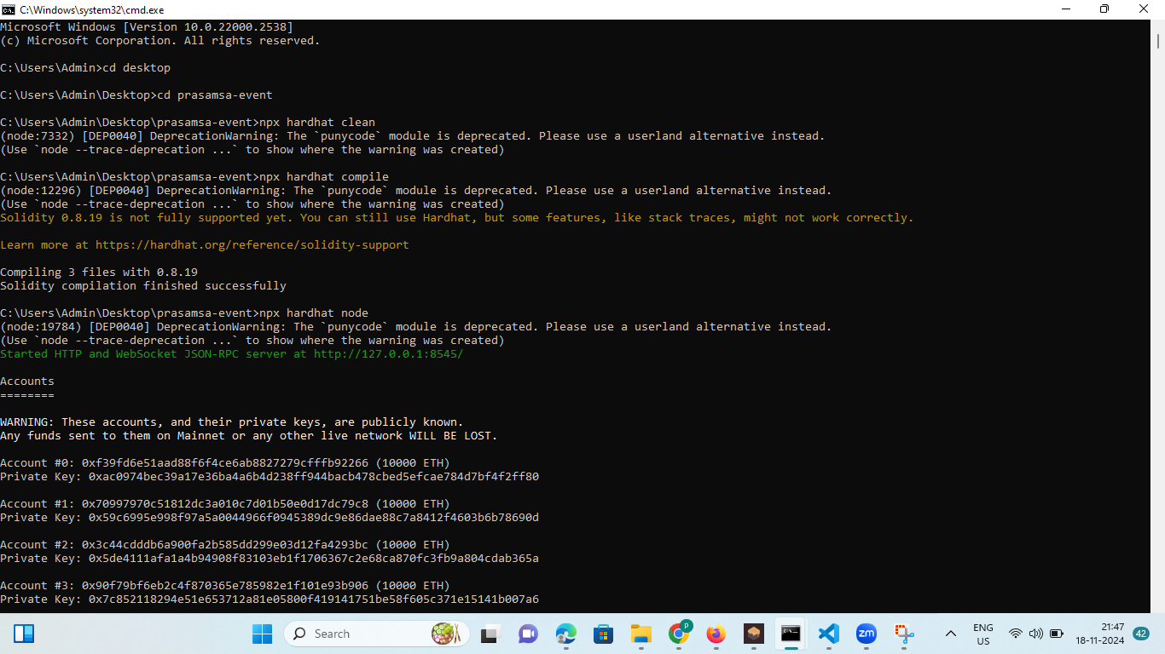

Step 2:successfully depolyed and got event ticketing service and greeter address

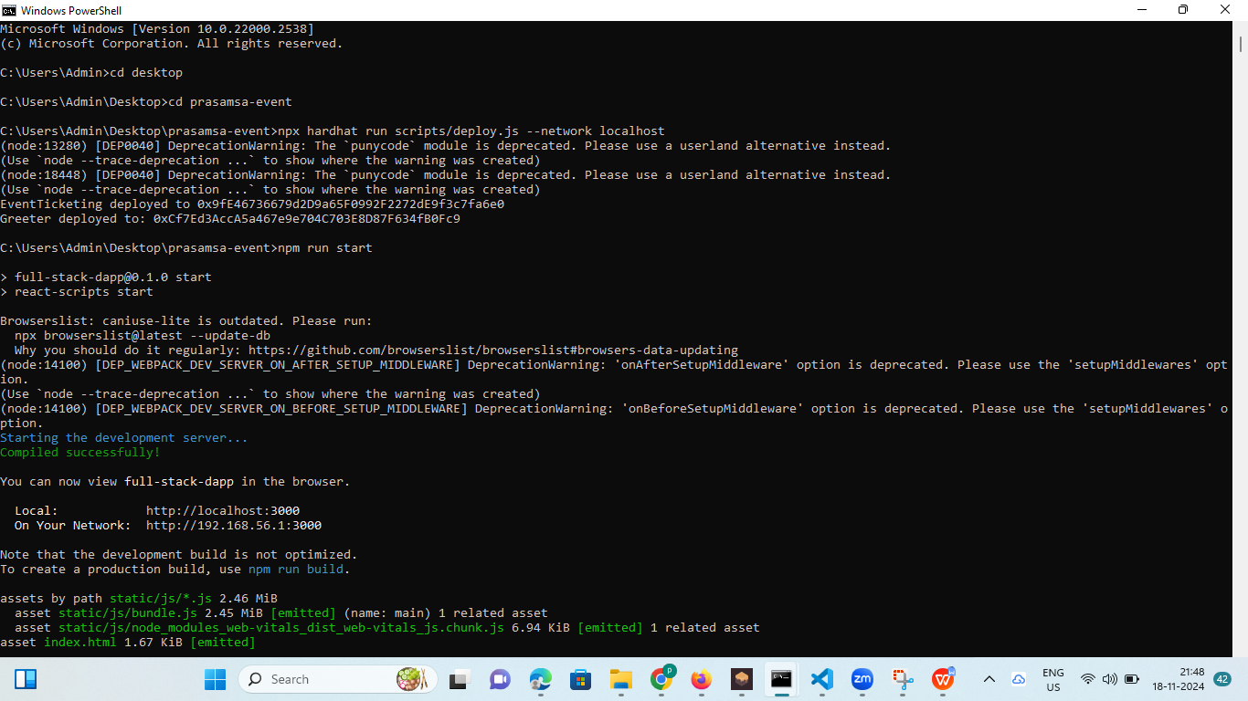

Step 3:npm start and I used react app in my project

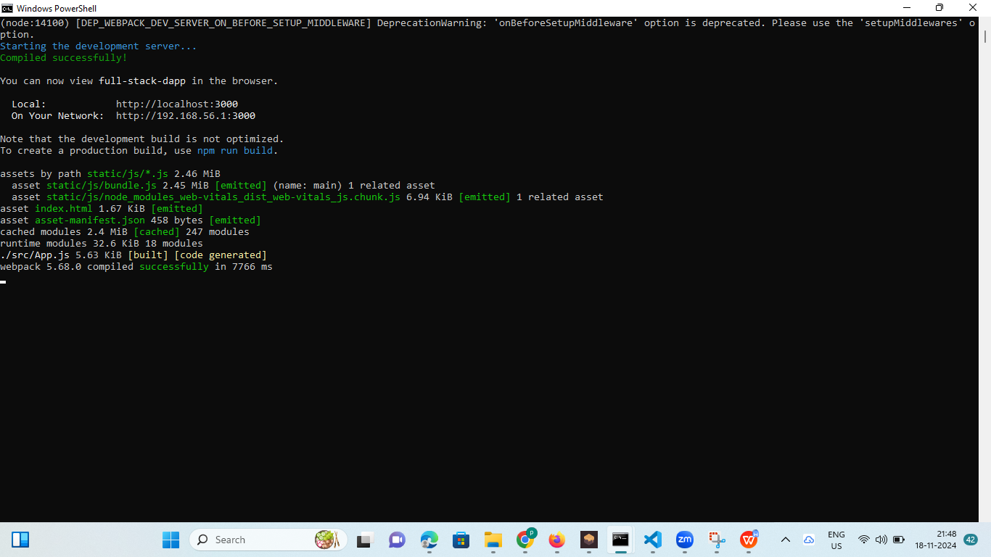

Step 4:this is my frontend

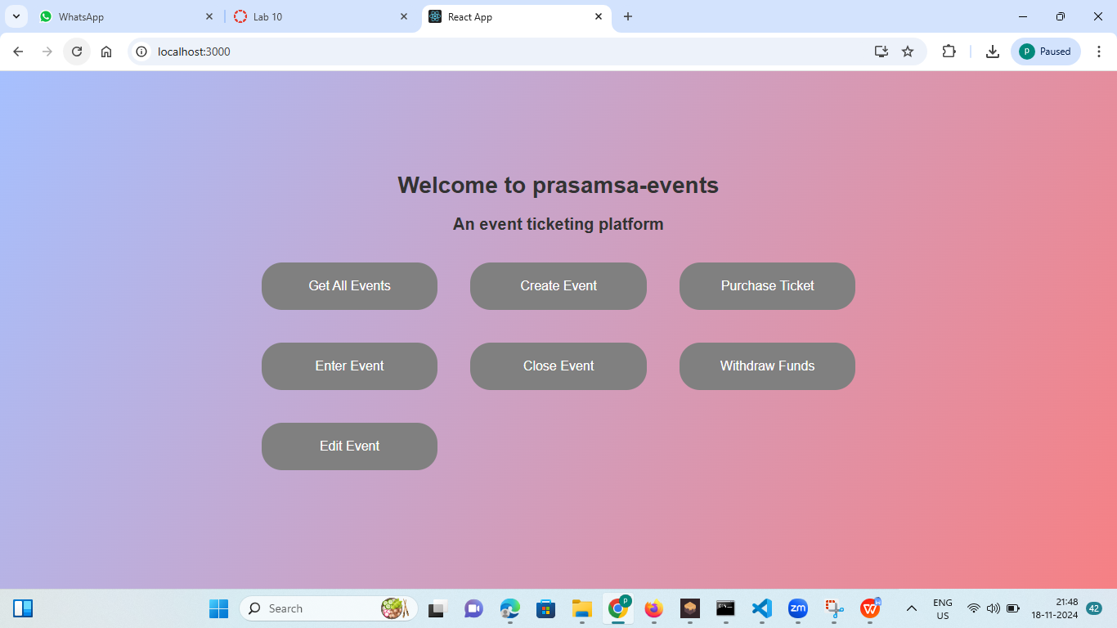

Creating event

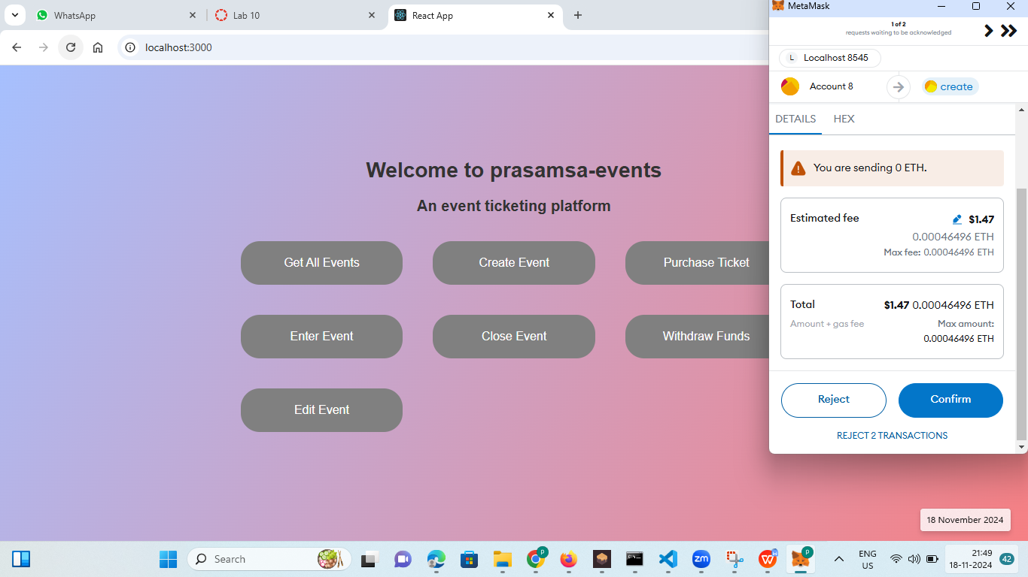

Purchasing ticket

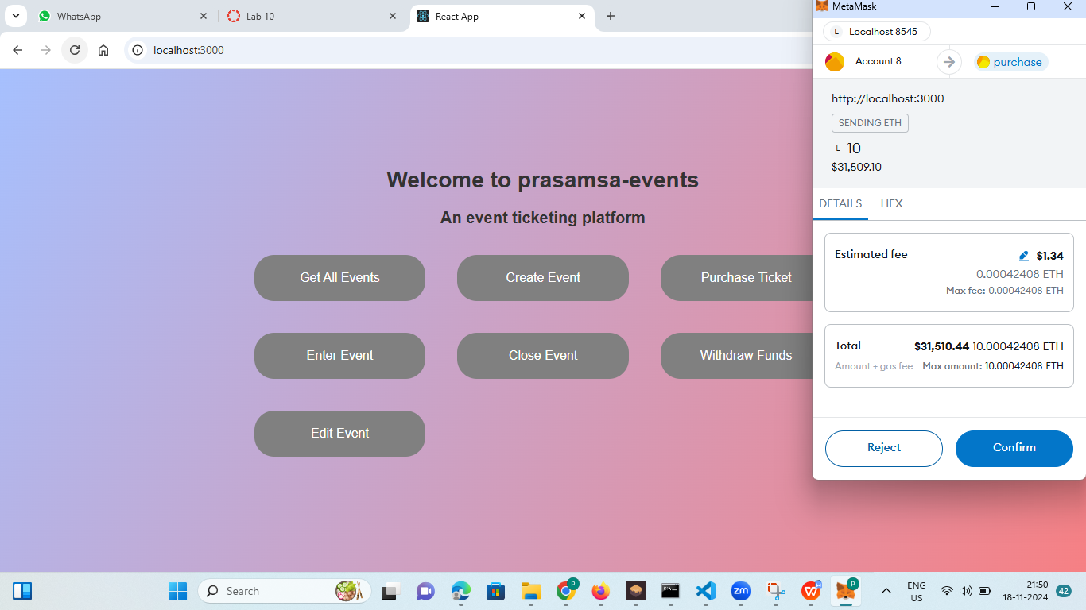

Withdrawl funds

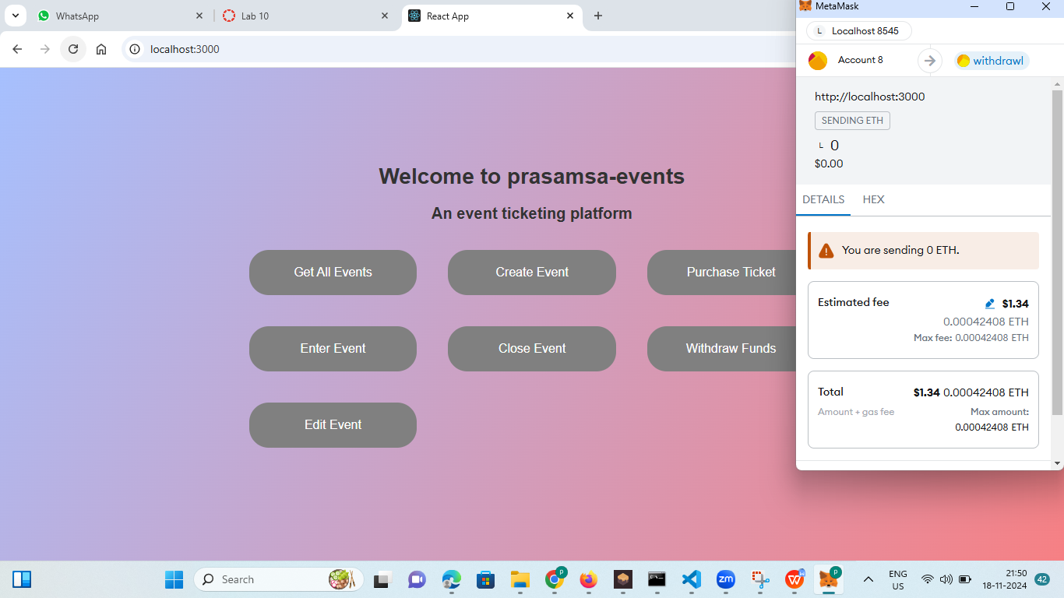

Check-In to the event

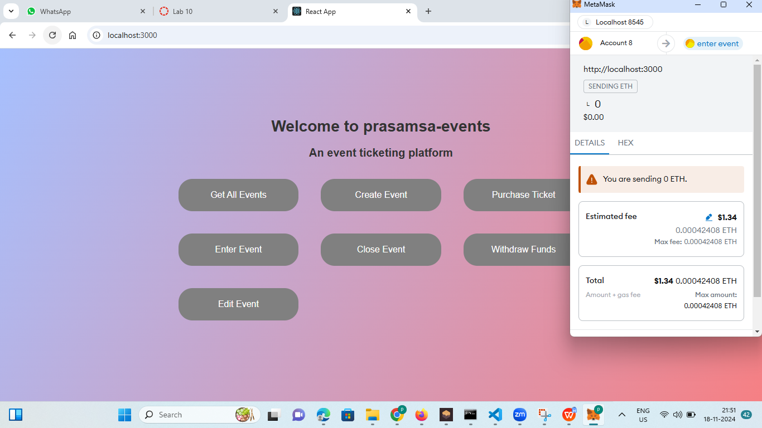

Event closing

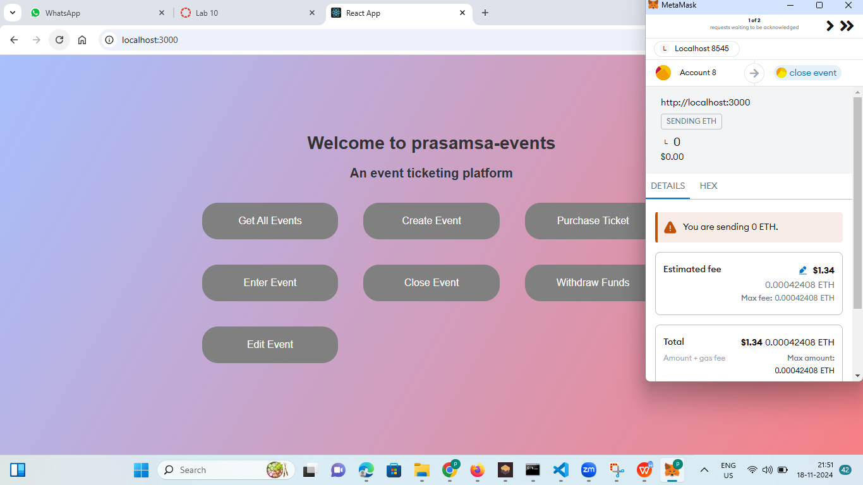

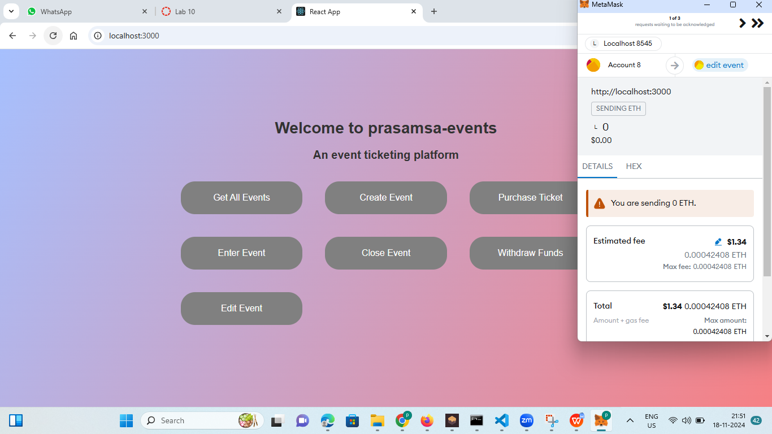

Console

